**PL/SQL programming**

**Exercise 1: Control Structures**

**Customers Table**

**Create:**

CREATE TABLE customers (

customer_id NUMBER PRIMARY KEY,

name VARCHAR2(100),

age NUMBER,

balance NUMBER,

isvip CHAR(1) DEFAULT 'N'

);

**Insert:**

INSERT INTO customers VALUES (1, 'Sara', 65, 15000, 'N');

INSERT INTO customers VALUES (2, 'Bansal', 45, 8000, 'N');

INSERT INTO customers VALUES (3, 'Vino', 70, 5000, 'N');

**Loans Table**

**Create:**

CREATE TABLE loans (

  loan_id NUMBER PRIMARY KEY,

  customer_id NUMBER REFERENCES customers(customer_id),

  interest_rate NUMBER,

  due_date DATE

);

**Insert:**

INSERT INTO loans VALUES (101, 1, 7.5, SYSDATE + 10);

INSERT INTO loans VALUES (102, 2, 8.0, SYSDATE + 45);

INSERT INTO loans VALUES (103, 3, 6.5, SYSDATE + 20);

**1.Write a PL/SQL block that loops through all customers, checks their age, and if they are above 60, apply a 1% discount to their current loan interest rates.**

BEGIN

FOR loan_rec IN (

SELECT l.loan_id, l.interest_rate, c.age

FROM loans l

JOIN customers c ON l.customer_id = c.customer_id

) LOOP

IF loan_rec.age > 60 THEN

UPDATE loans

SET interest_rate = interest_rate - 1

WHERE loan_id = loan_rec.loan_id;

END IF;

END LOOP;

COMMIT;

END;

**2. Write a PL/SQL block that iterates through all customers and sets a flag IsVIP to TRUE for those with a balance over $10,000.**

BEGIN

FOR cust_rec IN (

SELECT customer_id, balance

FROM customers

) LOOP

IF cust_rec.balance > 10000 THEN

UPDATE customers

SET isvip = 'Y'

WHERE customer_id = cust_rec.customer_id;

END IF;

END LOOP;

COMMIT;

END;

**3.Write a PL/SQL block that fetches all loans due in the next 30 days and prints a reminder message for each customer.**

BEGIN

FOR loan_rec IN (

SELECT l.loan_id, c.name, l.due_date

FROM loans l

JOIN customers c ON l.customer_id = c.customer_id

WHERE l.due_date BETWEEN SYSDATE AND SYSDATE + 30

) LOOP

DBMS_OUTPUT.PUT_LINE('Reminder: Loan ID ' || loan_rec.loan_id ||

' for ' || loan_rec.name || ' is due on ' || TO_CHAR(loan_rec.due_date, 'DD-MON-YYYY'));

END LOOP;

END;

**OUTPUT:**

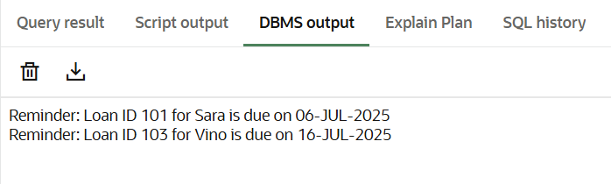

**OUTPUT**

SELECT * FROM customers;

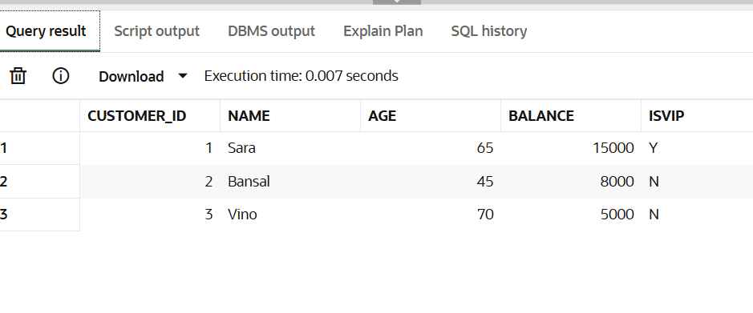

SELECT * FROM loans;

